**Output:-**

**Server**

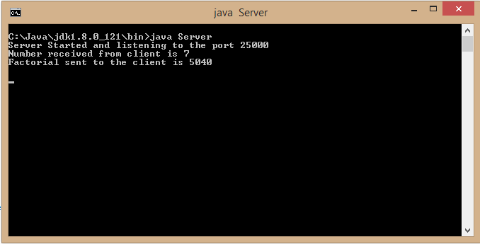

**Client**

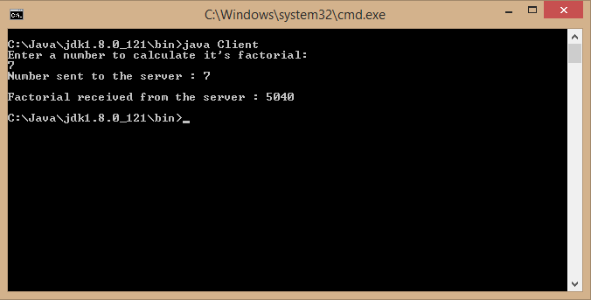

**Conclusion:-** Thus, we have understood the concept of LPC and RPC and have implemented the same, to make a simple client server model to calculate factorial of a number.